**CSE 2320 - Homework 4** NAME:__Joshua Abuto___________________________________

Total points: 100 Topics: Recurrences , solved with methods: Master Theorem, Tree

$$Convention: \left\lceil \right\rceil means rounded up and \left\lfloor \right\rfloor means rounded down.$$

**P1**. (**23 points**) Use the tree and table method to compute the **Θ** time complexity for . Assume T(0) = 1 and T(1) = 1. Fill in the table below and finish the computations outside of it:

|  |  |  |  |  |
| --- | --- | --- | --- | --- |
| Level | Argument/  Problem size | Cost of one node | Nodes per level | Cost of whole level |
| *0* | n | 2n3 | 1 | 2n3 |
| *1* | n/4 | 2(n/4)3 | 5 | 5*2*(n/4)3= 2n3*(5/43) |
| *2* | n/42 | 2(n/42)3 | 52 | 52*2*(n/42)3=2n3*(5/43)2 |
| *…* |  |  |  |  |
| *i* | n/4i | 2(n/4i)3 | 5i | 5i*2*(n/4i)3=2n3*(5/43)i |
| *…* |  |  |  |  |
|  |  |  |  |  |
| *k=log4n*  *Leaf level.*  *Write k as a function of N.* | 1  (n/4k) | 2 = 2*1 = 2(n/5k)3 | 5k | 5k*2*(n/4k)3=2n3*(5/43)k |

Total tree cost calculation: **2n3+2n3*(5/43)+2n3*(5/43)2 +…+2n3*(5/43)k =**

T(N) = Θ(N3)

Draw the tree. Show **levels 0,1,2** and the **leaves level**. Show the problem size T(…) as a label next to the node and inside the node show the local cost (cost of one node) as done in class. For the leaf level and level 2 it suffices to show a few nodes.

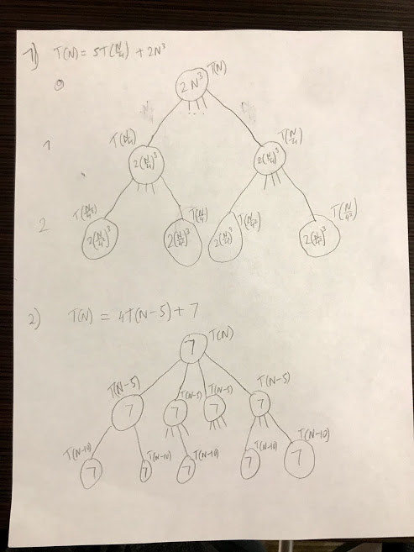

**P2**. (23 **points**) Use the tree and table method to compute the **Θ** time complexity for $T\left(N\right)=4T\left(N-5\right)+7$. Assume T(N) = 7 for all 0≤N≤4. Assume N is a convenient value for your computations.

Fill in the table below and finish the computations outside of it:

|  |  |  |  |  |
| --- | --- | --- | --- | --- |
| Level | Argument/  Problem size | Cost of one node | Nodes per level | Cost of whole level |
| *0* | N | 7 | 1 | 1*7 |
| *1* | n-5 | 7 | 41 | 4*7 |
| *2* | n-5*2 | 7 | 42 | 42*7 |
| *3* | n-5*3 | 7 | 43 | 43*7 |
| *4* | n-5*4 | 7 | 44 | 44*7 |
| *…* |  |  |  |  |
| *i* | n-5*i | 7 | 4i | 4i*7 |
| *k=*  *Leaf level.*  *Write k as a function of N.* | n-5*k | 7 | 4k | 4k*7 |

Total tree cost calculation: 7+4*7+42*7+…+4i*7+…+4k=

T(N) = Θ($4^{n}$)

Draw the tree. Show **levels 0,1,2** and the **leaves level**. Show the problem size T(…) as a label next to the node and inside the node show the local cost (cost of one node) as done in class. For the leaf level and level 2 it suffices to show a few nodes.



**P3**. (**50 points**) Can you use the Master Theorem to solve the recurrences below? If yes, solve it with this method, if no, show why you cannot use it. If you need show O,Ω, or Θ, use the limit theorem to show it.

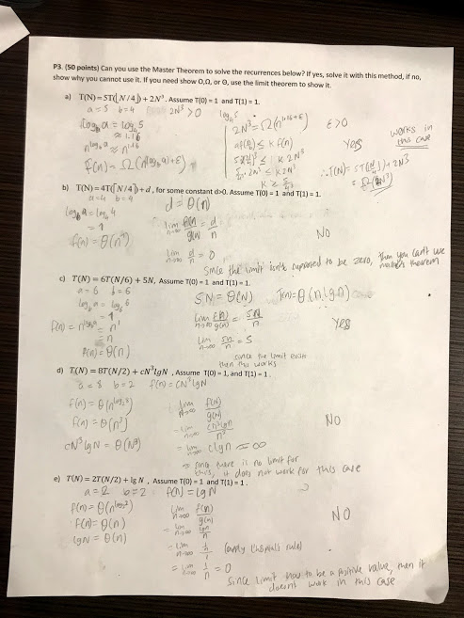

**P4.** (**4 points**) Go to the Wikipedia webpage <https://en.wikipedia.org/wiki/Master_theorem_(analysis_of_algorithms)> . See section “Inadmissible equations” and list the equation and the reason why it does not satisfy the Master Theorem requirements.

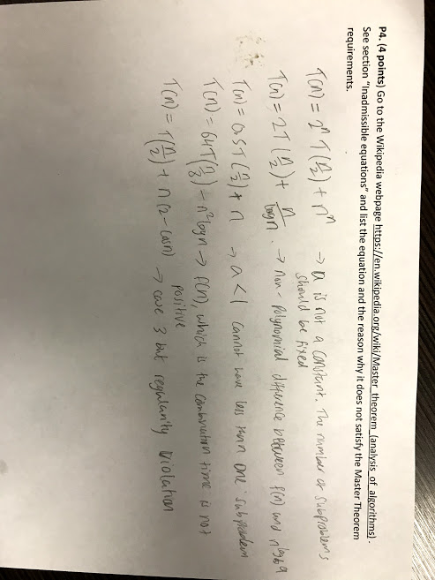

Write your answers in a document called **2320_H4.pdf**. It can be hand-written and scanned, but it must be uploaded electronically. Submit just the 2320_H4.pdf.

Remember to include your name at the top.